1. Basic algorithmic thinking in R

1.1 Lowest temperature manual calulation

Screenshot of created function for lowest temperature

Print function that prints the result of the function.



Screenshot of created function for highest temperature

Screenshot of created function for average temperature

#step2

#Enter the name of 10 cities and their temperature for each day in 1 month

#The print the min, max and average temperature using borh own functions an

#built in functions

for(i in 1:10){

city <- (c(readline(prompt = "Enter cityname: ")))

temp <- tempInCity()

cat("Own function lowest temperature in", city ,"is", lowestTemperature(temp), "degrees\n")

cat("Built in lowest temperature in", city ,"is", min(temp),"degreees\n")

cat("Own function highest temperature in", city ,"is", highestTemperature(temp), "degrees\n")

cat("Built in highest temperature in", city ,"is", max(temp),"degreees\n")

cat("Own function average temperature in", city ,"is", averageTemperature(temp), "degrees\n")

cat("Built in average temperature in", city ,"is", mean(temp),"degreees\n")

}

1. This dataset is about chronic Kidney Disease in India and contain around 25 columns of data, data such as red blood cell count, whte blood cell count Some missing values saying NA that I have replaced with mean values for that particular column. Also some with empty fields that I first had to replace with na before I could calculate mean on those columns too and replace the na’s with mean values.

Another way to do it would be to delete all rows where there is NA or empty values but that would leave the dataset with only 158 out of 400 rows left.

1. Using the built in dataset called mtcars showing the relationship between horsepower and the miles per gallon fuel.  
     
   plot(mtcars$mpg,mtcars$hp)

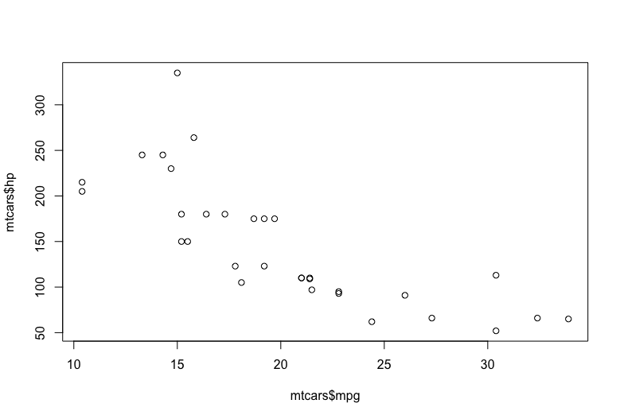

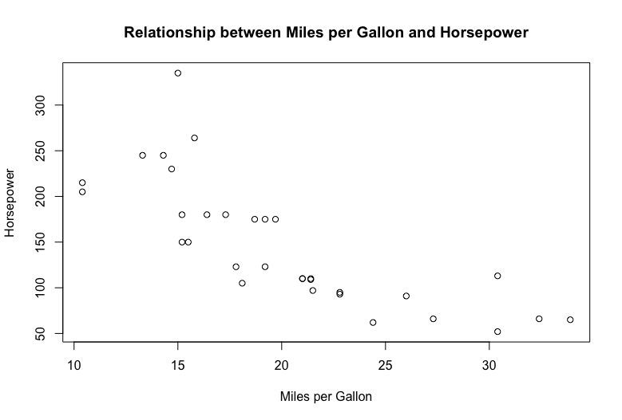

plot(mtcars$mpg,mtcars$hp, type = "h",

main = "Relationship between Miles per Gallon and Horsepower",

xlab = "Miles per Gallon",

ylab = "Horsepower")

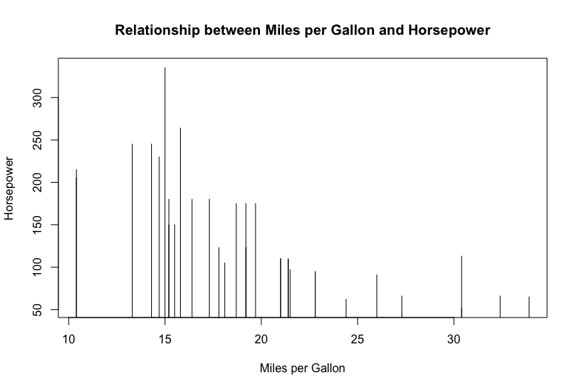

1. I have created a cash registry application where you can buy differend breakfast products.En bild som visar text

   Automatiskt genererad beskrivning